**Practical Related Questions**

1. **Write in detail which methods are needed to implement Content Provider class.**

Following are the six abstract methods and their description which are essential to override as the part of ContenProvider class:

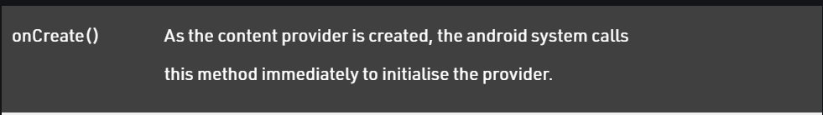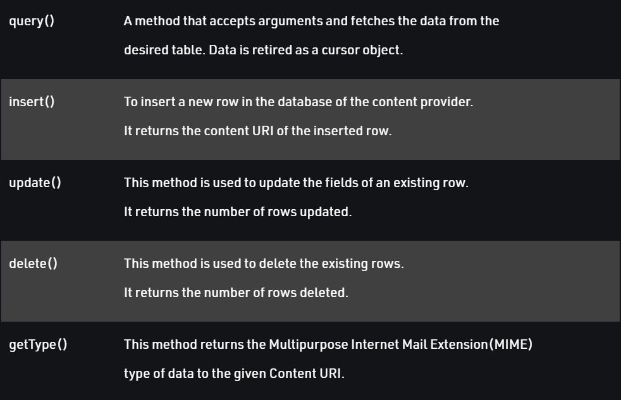

1. **Explain different parts of an URI in android application. Also write the format of URI.**

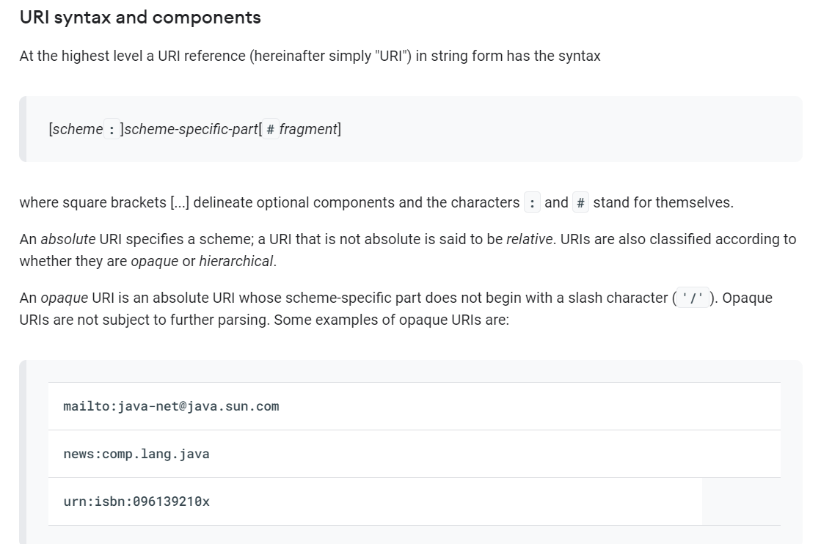

1. **Write steps to create a content provider in android applications.**
2. Create a class that extends ContentProvider.
3. Create a contract class.
4. Create the UriMatcher definition.
5. Implement the onCreate() method.
6. Implement the getType() method.
7. Implement the CRUD methods.
8. Add the content provider to your AndroidManifest. xml.

**Exercise**

**MainActivity.java**

package com.example.contentprovidereg;  
  
import androidx.appcompat.app.AppCompatActivity;  
  
import android.content.ContentValues;  
import android.content.Context;  
import android.database.Cursor;  
import android.net.Uri;  
import android.os.Bundle;  
import android.view.LayoutInflater;  
import android.view.MotionEvent;  
import android.view.View;  
import android.view.ViewGroup;  
import android.view.inputmethod.InputMethodManager;  
import android.widget.CursorAdapter;  
import android.widget.EditText;  
import android.widget.ListView;  
import android.widget.TextView;  
import android.widget.Toast;  
  
public class MainActivity extends AppCompatActivity {  
  
 @Override  
 protected void onCreate(Bundle savedInstanceState) {  
 super.onCreate(savedInstanceState);  
 setContentView(R.layout.*activity_main*);  
 }  
  
 @Override  
 public boolean onTouchEvent(MotionEvent event){  
 InputMethodManager imm = (InputMethodManager)getSystemService(Context.*INPUT_METHOD_SERVICE*);  
 imm.hideSoftInputFromWindow(getCurrentFocus().getWindowToken(), 0);  
 return true;  
 }  
  
 public void onClickAddDetails(View view){  
 ContentValues values = new ContentValues();  
  
 values.put(MyContentProvider.*name*, ((EditText) findViewById(R.id.*textName*)).getText().toString());  
  
 getContentResolver().insert(MyContentProvider.*CONTENT_URI*, values);  
  
 Toast.*makeText*(getBaseContext(), "New Record Inserted", Toast.*LENGTH_LONG*).show();  
 }  
  
 public void onClickShowDetails(View view){  
 TextView result = (TextView) findViewById(R.id.*res*);  
  
 Cursor c = getContentResolver().query(Uri.*parse*("content://com.demo.user.provider/users"), null, null, null, null);  
  
  
 if(c.moveToFirst()){  
 StringBuilder str = new StringBuilder();  
 while(!c.isAfterLast()){  
 str.append("\n" + c.getString(c.getColumnIndex("id")) + ":- " + c.getString(c.getColumnIndex("name")));  
 c.moveToNext();  
 }  
 result.setText(str);  
 }  
 else{  
 result.setText("No Records Found");  
 }  
 }  
}

**MyContentProvider.java**

package com.example.contentprovidereg;  
  
import androidx.appcompat.app.AppCompatActivity;  
  
import android.content.ContentValues;  
import android.content.Context;  
import android.database.Cursor;  
import android.net.Uri;  
import android.os.Bundle;  
import android.view.LayoutInflater;  
import android.view.MotionEvent;  
import android.view.View;  
import android.view.ViewGroup;  
import android.view.inputmethod.InputMethodManager;  
import android.widget.CursorAdapter;  
import android.widget.EditText;  
import android.widget.ListView;  
import android.widget.TextView;  
import android.widget.Toast;  
  
public class MainActivity extends AppCompatActivity {  
  
 @Override  
 protected void onCreate(Bundle savedInstanceState) {  
 super.onCreate(savedInstanceState);  
 setContentView(R.layout.*activity_main*);  
 }  
  
 @Override  
 public boolean onTouchEvent(MotionEvent event){  
 InputMethodManager imm = (InputMethodManager)getSystemService(Context.*INPUT_METHOD_SERVICE*);  
 imm.hideSoftInputFromWindow(getCurrentFocus().getWindowToken(), 0);  
 return true;  
 }  
  
 public void onClickAddDetails(View view){  
 ContentValues values = new ContentValues();  
  
 values.put(MyContentProvider.*name*, ((EditText) findViewById(R.id.*textName*)).getText().toString());  
  
 getContentResolver().insert(MyContentProvider.*CONTENT_URI*, values);  
  
 Toast.*makeText*(getBaseContext(), "New Record Inserted", Toast.*LENGTH_LONG*).show();  
 }  
  
 public void onClickShowDetails(View view){  
 TextView result = (TextView) findViewById(R.id.*res*);  
  
 Cursor c = getContentResolver().query(Uri.*parse*("content://com.demo.user.provider/users"), null, null, null, null);  
  
  
 if(c.moveToFirst()){  
 StringBuilder str = new StringBuilder();  
 while(!c.isAfterLast()){  
 str.append("\n" + c.getString(c.getColumnIndex("id")) + ":- " + c.getString(c.getColumnIndex("name")));  
 c.moveToNext();  
 }  
 result.setText(str);  
 }  
 else{  
 result.setText("No Records Found");  
 }  
 }  
}

**activity_main.xml**

<?xml version="1.0" encoding="utf-8"?>  
<androidx.constraintlayout.widget.ConstraintLayout  
 xmlns:android="http://schemas.android.com/apk/res/android"  
 xmlns:app="http://schemas.android.com/apk/res-auto"  
 xmlns:tools="http://schemas.android.com/tools"  
 android:layout_width="match_parent"  
 android:layout_height="match_parent"  
 android:background="#168BC34A"  
 tools:context=".MainActivity">  
  
 <LinearLayout  
 android:id="@+id/linearLayout"  
 android:layout_width="match_parent"  
 android:layout_height="wrap_content"  
 android:layout_centerVertical="true"  
 android:orientation="vertical"  
 app:layout_constraintBottom_toTopOf="@+id/imageView"  
 app:layout_constraintEnd_toEndOf="parent"  
 app:layout_constraintStart_toStartOf="parent"  
 app:layout_constraintTop_toTopOf="parent"  
 app:layout_constraintVertical_bias="0.13"  
 tools:ignore="MissingConstraints">  
  
 <TextView  
 android:id="@+id/textView1"  
 android:layout_width="match_parent"  
 android:layout_height="wrap_content"  
 android:layout_marginTop="40dp"  
 android:layout_marginBottom="70dp"  
 android:text="@string/heading"  
 android:textAlignment="center"  
 android:textAppearance="@style/TextAppearance.AppCompat.Large"  
 android:textColor="@android:color/holo_green_dark"  
 android:textSize="36sp"  
 android:textStyle="bold" />  
  
 <EditText  
 android:id="@+id/textName"  
 android:layout_width="match_parent"  
 android:layout_height="wrap_content"  
 android:layout_marginStart="20dp"  
 android:layout_marginEnd="20dp"  
 android:layout_marginBottom="40dp"  
 android:hint="@string/hintText" />  
  
 <Button  
 android:id="@+id/insertButton"  
 android:layout_width="match_parent"  
 android:layout_height="match_parent"  
 android:layout_marginStart="20dp"  
 android:layout_marginTop="10dp"  
 android:layout_marginEnd="20dp"  
 android:layout_marginBottom="20dp"  
 android:background="#4CAF50"  
 android:onClick="onClickAddDetails"  
 android:text="@string/insertButtontext"  
 android:textAlignment="center"  
 android:textAppearance="@style/TextAppearance.AppCompat.Display1"  
 android:textColor="#FFFFFF"  
 android:textStyle="bold" />  
  
 <Button  
 android:id="@+id/loadButton"  
 android:layout_width="match_parent"  
 android:layout_height="match_parent"  
 android:layout_marginStart="20dp"  
 android:layout_marginTop="10dp"  
 android:layout_marginEnd="20dp"  
 android:layout_marginBottom="20dp"  
 android:background="#4CAF50"  
 android:onClick="onClickShowDetails"  
 android:text="@string/loadButtonText"  
 android:textAlignment="center"  
 android:textAppearance="@style/TextAppearance.AppCompat.Display1"  
 android:textColor="#FFFFFF"  
 android:textStyle="bold" />  
  
 <TextView  
 android:id="@+id/res"  
 android:layout_width="match_parent"  
 android:layout_height="wrap_content"  
 android:layout_marginStart="20dp"  
 android:layout_marginEnd="20dp"  
 android:clickable="false"  
 android:ems="10"  
 android:textColor="@android:color/holo_green_dark"  
 android:textSize="18sp"  
 android:textStyle="bold" />  
  
 <ListView  
 android:layout_width="match_parent"  
 android:layout_height="match_parent"  
 android:id="@+id/liv">  
 </ListView>  
  
 </LinearLayout>  
  
 <ImageView  
 android:id="@+id/imageView"  
 android:layout_width="wrap_content"  
 android:layout_height="wrap_content"  
 app:layout_constraintBottom_toBottomOf="parent"  
 app:layout_constraintEnd_toEndOf="parent"  
 app:layout_constraintStart_toStartOf="parent"  
 />  
  
</androidx.constraintlayout.widget.ConstraintLayout>